Measuring PalladioFileShare – file _______________________

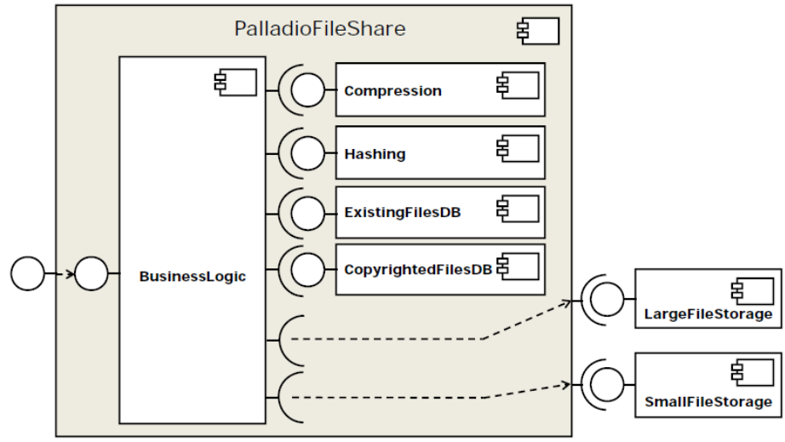

Measurements | Class for measuring / benchmarking | Lenovo -Xint / JIT [ns] | Toshiba -Xint / JIT [ns] | Notizen
1. Compress | CompressBenchmarker
2. Get Hash | HashBenchmarker
3. Query ExistingDB | ExistingDatabaseBenchmarker
4. Query CopyrightDB | CopyrightDatabaseBenchmarker
5. Store small file | [SmallFile]  StorageBenchmarker
6. Store large file | [SmallFile]  StorageBenchmarker
7. Entire application (business logic) | EntireApplicationBenchmarker (???)
JIT effects and relocation/sizing | JITSpeedupQuantifier | n/a | n/a

TestDriver.start --> TODO: document control flow and data flow

Print and fill this sheet as needed
Systematic benchmarking especially needed for JIT case!
Class SimpleLZW, method lzwcompress_inlined
Consult legacy package and ByCounter for random input generation, etc. Here, concentrate on the set of input files.
Class Hash, method getMessageDigest
Class ExistingFilesDatabase, methods existsInDatabase and addNewFileHash
Class CopyrightedMaterialDatabase, method isCopyrightedMaterial
Class Storage, method storeFile
Currently implemented by the same Storage class as „Store large file“
Class Storage, method storeFile
Currently implemented by the same Storage class as „Store small file“
Class BusinessFacade, method uploadFiles, sequentially driven by method start of class TestDriver

